Mina is a cheerful little girl. Today, she puts on her favorite blue hat and gets ready to explore her backyard.

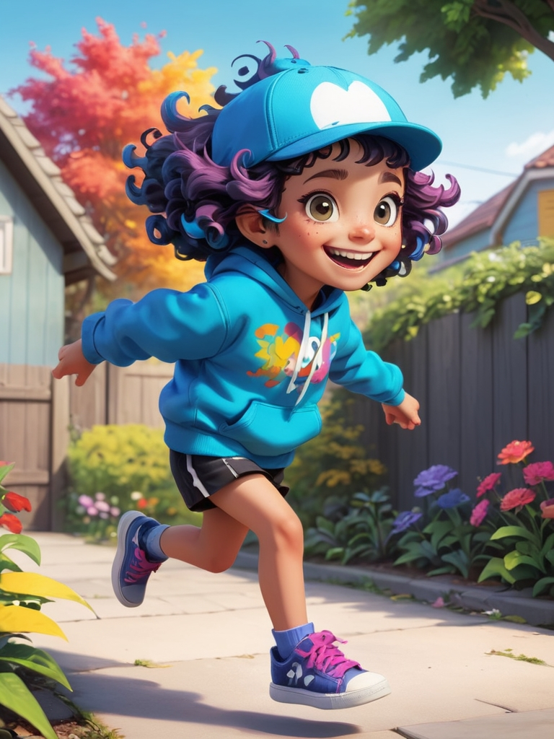 Image 1 girl who loves to laugh

She walks into the garden and finds a lost little kitten. The kitten looks a little scared, and Mina gently says, “Don’t worry, I’ll help you.”

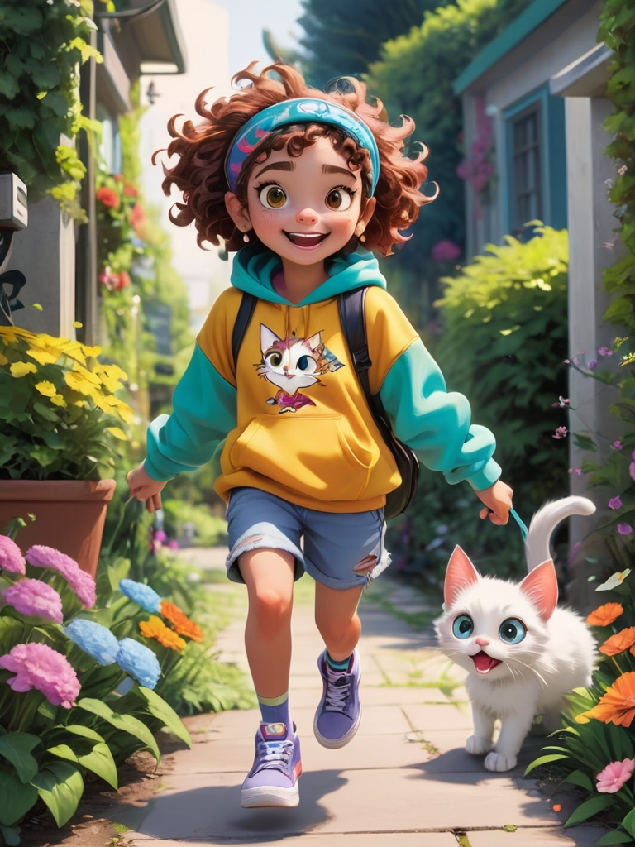 Image 2 gentle girl

Mina carefully picks up the kitten and starts looking for its home. She asks every animal, “Have you seen this little kitten?”

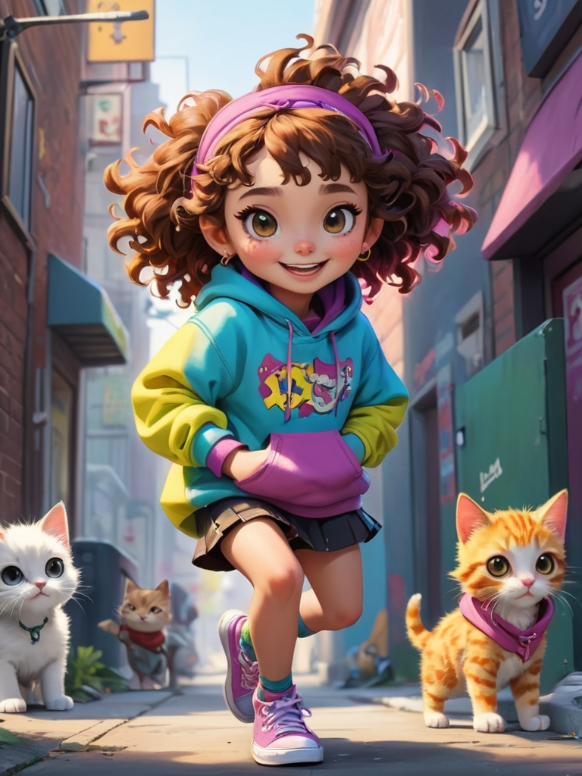 Image 3 attentive girl

Mina meets a rabbit, and the rabbit points to a big tree, saying, “The kitten might be over there!” Mina walks towards that direction.

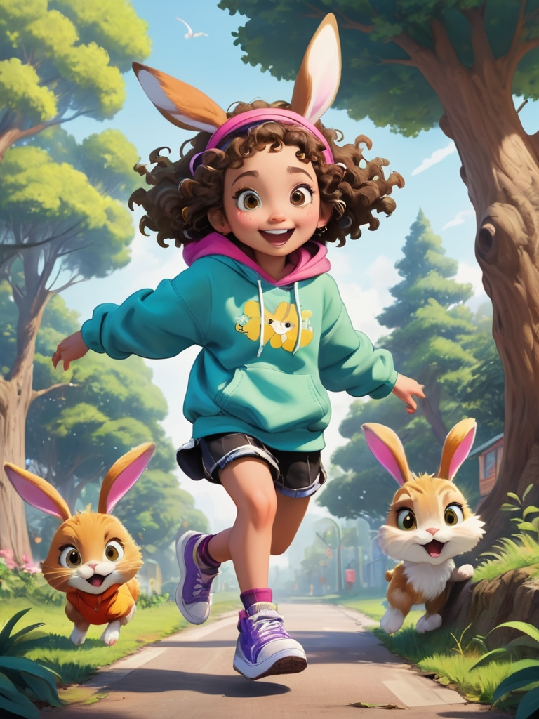 Image 4 happy girl

Mina arrives at the big tree and finds the kitten’s home inside a tree hole. She happily tells the kitten, “You’re home!”

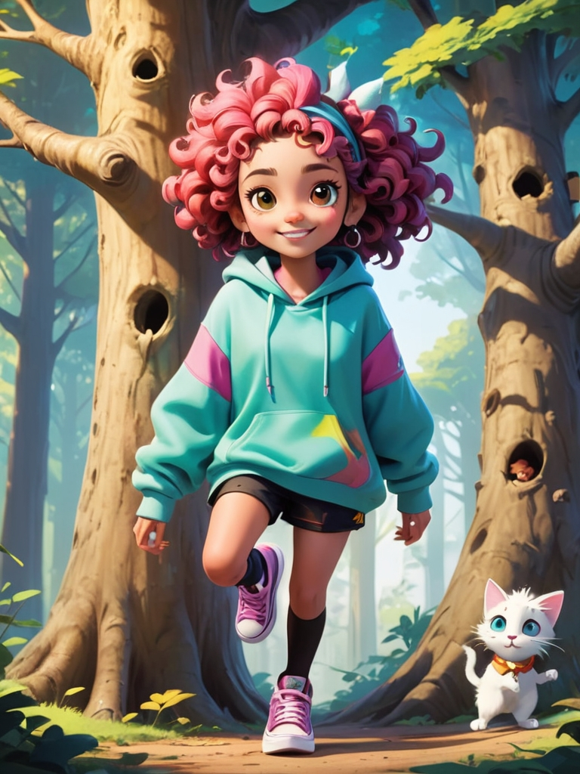 Image 5 happy laughing girl

The kitten jumps into the tree hole, wagging its tail in joy. It thanks Mina. Mina smiles and says, “Helping others makes me so happy!”

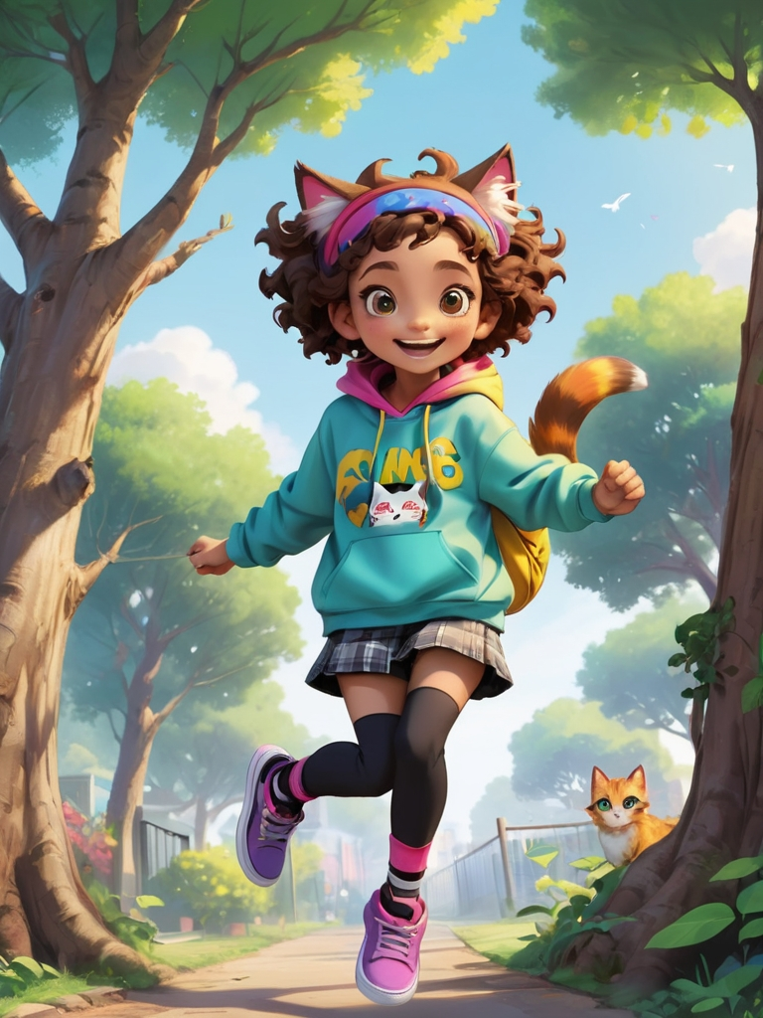 Image 6 A girl who loves to help others

Mina continues to play in the garden, when suddenly, she hears a noise. It turns out that a little bird has fallen from the tree.

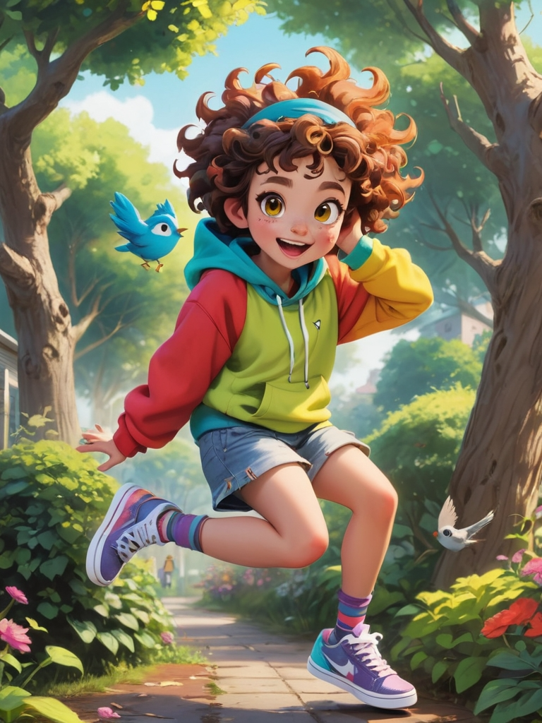 Image 7 girl playing

Mina gently puts the little bird back on the tree, saying, “Be careful, don’t fall again!” The little bird thanks her and happily flies back to the tree.

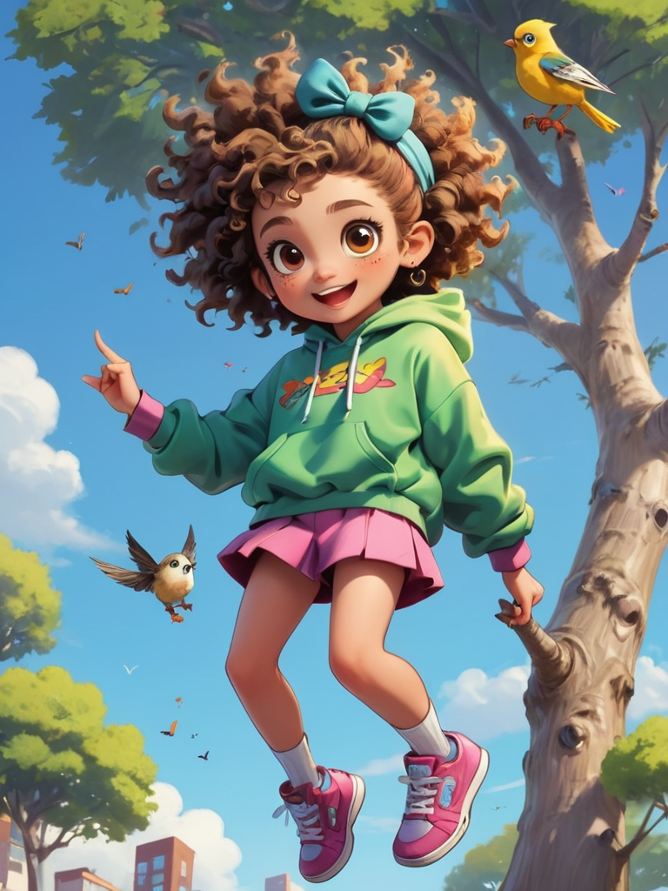 Image 8 helpful girl

Mina sits on a bench in the garden, listening to the sound of wind chimes, feeling very happy. She thinks today is really special.

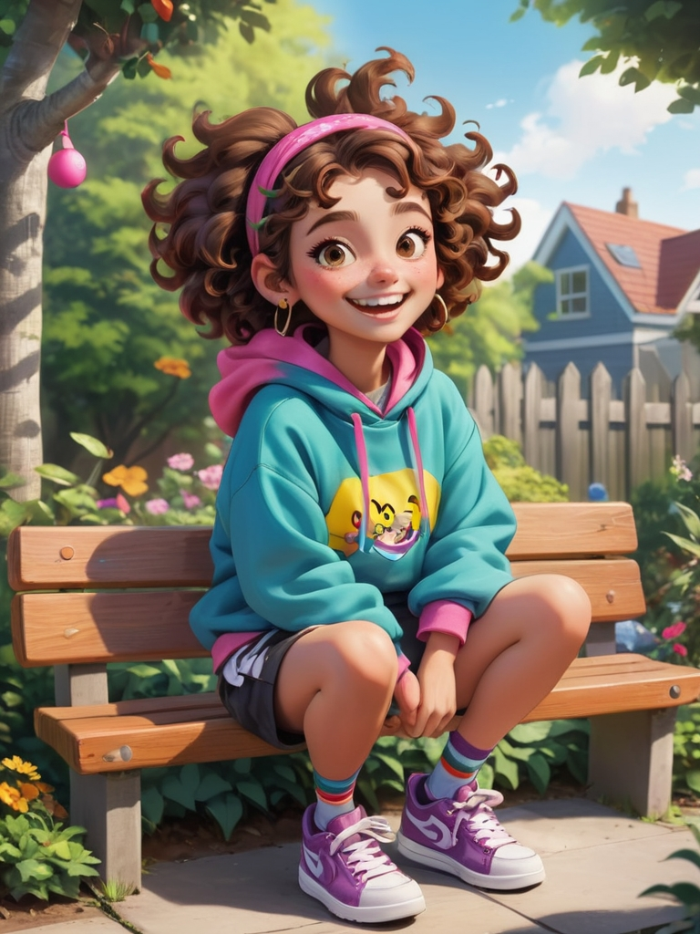 Image 9 Very happy girl

As the sun sets, Mina returns home and tells her mom about her adventure today. She has learned the joy of helping others and understands the value of sharing happiness.

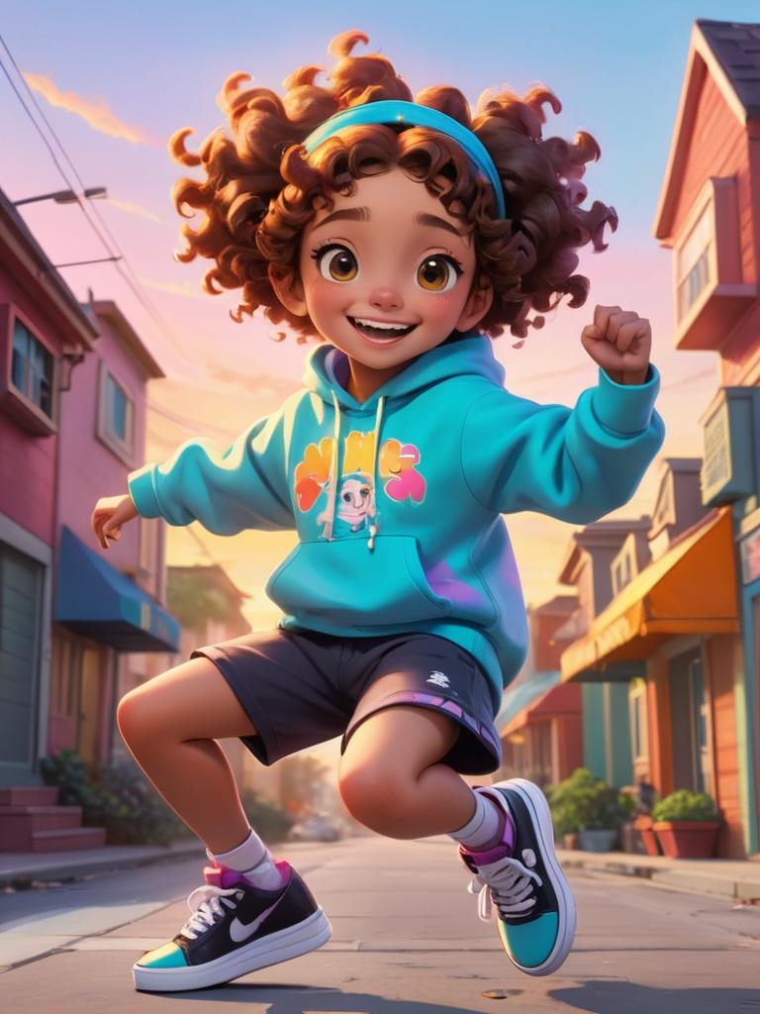 Image 10 adventurous girl